Ecosystems Advance Preparation Needed
Advance preparation for NetLogo simulations and other technology requirements
This document will help you identify the lessons that require more significant advanced preparation to plan for technology needs.
Lesson | Time | Advanced Preparation Needed
7, 8, 14 | 1 month before teaching | NetLogo simulation advance preparation  About 1 month prior to using the NetLogo simulations, decide how you want students to access the simulations (via URL or downloaded .html files). Work with your technology support staff to ensure access to the files is not blocked and that the simulations run on your device(s) accurately. Additional guidance on options for accessing the NetLogo simulations is included on the following pages.  The simulations have been tested on both Apple and PC products. They work on HP chromebooks, Apple Macbooks, and smart boards. The speed of the simulation is notably slow on Apple iPad Airs. If you notice the speed slow down too much, consider:  - Clicking the “Show-trees” button to OFF  - Changing the “Show-orangutans” button to “show arrowhead”  These two modifications should speed up the simulation.  Email Lindsey Mohan, lmohan@bscs.org if you and your technology support staff encounter an issue or bug with the NetLogo simulations.
14 | 2 weeks before teaching | Crop Calculator Tool advance preparation  The Crop Calculator Tool is a spreadsheet-based calculator that students will use to test whether their ideas for diversified crops will financially support a farmer and family. The tool is provided as a Google sheet or an Excel file. Decide which format is most accessible to your class and either (1) make a copy to place on your class’ Google drive or Google classroom or (2) download the Excel file and redistribute to students via your class’ website, Google classroom, or email (or whichever method you use to share resources with students). Alternatively, work with your technology support staff to download the tool to student devices prior to the lesson.
6, 12 | 1 week before teaching | StoryMap advance preparation  StoryMaps are an interactive way to communicate information using mapped data, text, and other visual representations. StoryMaps are used in Lessons 6 and 12. Students engage with the StoryMaps in small groups on a shared device or on their own device if you have a 1-to-1 classroom.  Test the StoryMap Links ahead of time, via the field test website or using the tinyurls below:  - Lesson 6: https://tinyurl.com/orangutanstorymap  - Lesson 12: https://tinyurl.com/prairiestorymap and https://tinyurl.com/coffeestorymap  Once accessed, decide how best to share the StoryMap URLs with students on the day of instruction.  If internet connectivity is an issue or if you struggle with securing enough devices for small group work, printable handout versions of the StoryMap data and information are provided on the field test website.

Access to the NetLogo simulations
There are two ways to access the NetLogo simulations:
- From the field test website, click on the URL link, or
- From the field test Google Drive, download the simulations to your device(s).

Option 1: Access by URL
- Visit the field test website: https://www.teachersopensciedfieldtest.org/
- Navigate to the Palm Oil page.
- Scroll down to “Media and Interactives”.
- Locate the NetLogo section.
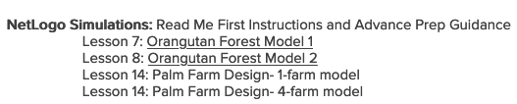
- Click on the linked file next to the lesson you are teaching.
- Give your students the tinyurl to type into their device.
Lesson 7 | Orangutan Forest Model 1 | https://tinyurl.com/forestmodel1
Lesson 8 | Orangutan Forest Model 2 | https://tinyurl.com/forestmodel2
Lesson 14 | Palm Farm Design: 1 Farm  Palm Farm Design: 4 Farms | https://tinyurl.com/palmfarmdesign1  https://tinyurl.com/fivefarmdesign

Option 2: Access by downloading the simulations to your device(s)
- Open this folder or navigate to the folder: OpenSciEd Public→ Field Test Version Docs→ Palm Oil→ Palm Oil Simulations and Spreadsheets.
- Click on the link for the name of the .html file that is the simulation you need to run.
Lesson 7 | Lesson 7 Orangutan Simulation
Lesson 8 | Lesson 8 Orangutan Simulation
Lesson 14 | Lesson 14 One Farm Design Simulation  Lesson 14 Five Farm Design Simulation

- You will see a file open that looks like this:
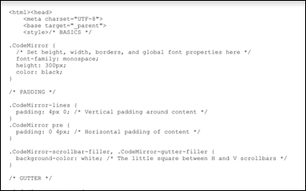

- Press the download link in the top right corner to get a copy of the file downloaded onto your computer.
- By default the file will be downloaded to your “download folder”. You will need to access the file through your finder or desktop. When you locate it, double click on it. Your default browser will now launch it as a simulation. If you have html editor software on your computer, download the file and manually select the browser you want to use or else the editor software will be the default.
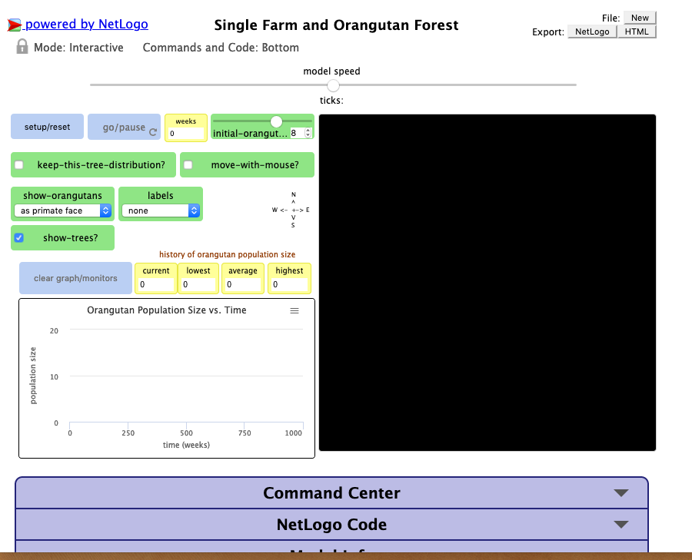

- You can play the simulation from your device and from students’ devices if it is downloaded in this way prior to the lesson.
Alternate method:
- You can email the .html file you downloaded to students or you can push the file out to students using a file distribution system in your school.
- In either case, students will need to save the file to their device before double-clicking on it to run the simulation.

